

Assignment -2
Critical Path Methods
- Solve the below mentioned question of excel sheet.
- Solve assignment must be uploaded on LMS by 20th October 25
- Marks - 5

Question # 1
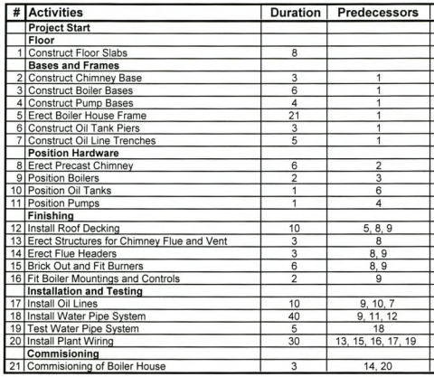

Question # 2

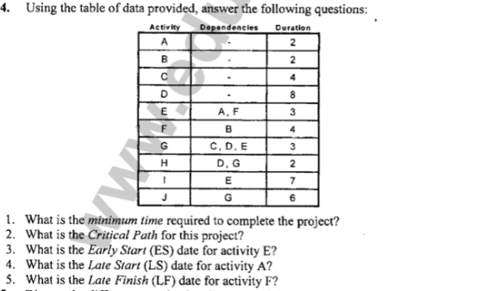
Question # 3

